**ENMORE**

**SPEED MANAGEMENT PROGRAM**

**A Green and Safe Village**

**For Users of the Enmore Road**

**2021/2022/2023**

  



  

 

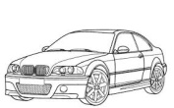 

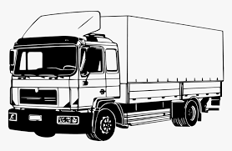

**By Enmore Parish Council**

**Contents**

**Page**

Introduction 3

Background 4

Phase 1 - Installation of SIDs by Parish Council 7

Phase 2 – Install 30mph through whole village 9

Phase 3 – Enforce 20mph outside school only when needed 10

Summary 11

**Enmore, Quantock Village – part of an Area of Outstanding Natural Beauty (AONB)**

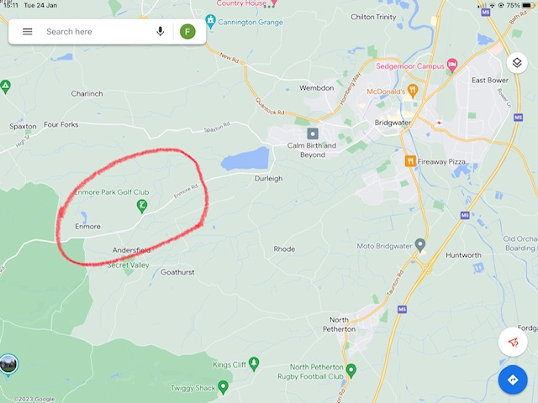

**Introduction**

The Speed Management Program for Enmore was reappraised by Enmore Parish Council in 2021 after a sharp rise in the level of complaints regarding the excess speeds observed on the Enmore Road.

During 2022, three Speed Indicator Devices (SIDs) were purchased and installed by Enmore Parish Council in an effort to improve compliance with the speed limit on the Enmore Road. A fourth SID is to be installed in early 2023. These SIDs currently cover two of the three sections of road within the parish with 30mph speed limits.

The figures produced by the SIDs, both in spy and active mode, clearly indicate that the SIDs slow down the traffic when in active mode and significantly increase the proportion of vehicles driving within or close to the speed limit (30mph in this case). When not active, the average speed of the traffic reverts to its previous pattern with many vehicles exceeding the speed limit.

This is due, in part, to the complicated and unintuitive speed limits throughout the length of the village. **There are in fact FOUR speed limit changes within the village boundaries**. Clearly the number of speed limit changes makes it confusing to the passing motorist and hard to adhere to even if there is a will to do so. In addition, the current speed limits are not seen as sensible in their placement, leading to their being disrespected.

The 30mph sections are relatively straight road. However, the 40mph section has several blind corners, a section prone to flooding and the potential hazards of the adjacent entries/exits for both the Enmore Village Hall and Enmore Park Golf Club. The Enmore Golf Club itself has an estimated 120 vehicles/day during the winter which increases to 180 vehicles/day during the summer.

The Enmore Road is used by pedestrians (including children), joggers, cyclists (it is on a key cycle route), horses including racehorses, moving farm stock, tractors and other farm traffic, cars, vans, transit vans and articulated lorries.

The need to slow traffic is not just for safety reasons, which are paramount, but other factors that are valid are to better maintain road surface integrity and to promote a greener environmental approach**. To be both a GREEN and safe village.**

In addition, the Highways Department at County would be in a difficult position should there be a serious accident or a fatality as the speed limits on the Enmore Road are not fit for purpose for the current and increasing volumes of commuter and business traffic.Our concerns about road safety have been raised before but Highways Department has not considered them sufficiently high priority to take any action. Many people who would walk or cycle short journeys within the village are deterred from doing so because of the safety concerns. Resolving these issues would encourage true carbon-free travel and improve wellbeing. An accident, particularly if an Enmore resident is affected and therefore known to all residents, will incur severe reputational damage to Somerset’s Highways Department and will set back the goal of more active travel by many years.

Enmore Parish Council has put its money where its mouth is to support safety on the Enmore Road by purchasing and installing three, soon to be four, SIDs within the village 30mph sections. It has taken what action it can within its power.

**In addition to the SID installations, Enmore Parish Council is asking the Highways Department to support their application for**

1. **A 30mph speed limit for the entire length of Enmore Village**
2. **To convert the current 24/7 20mph limit outside the school to a flashing “school hours only” sign**

**Background**

**Enmore Speed Limits Today January 2023**

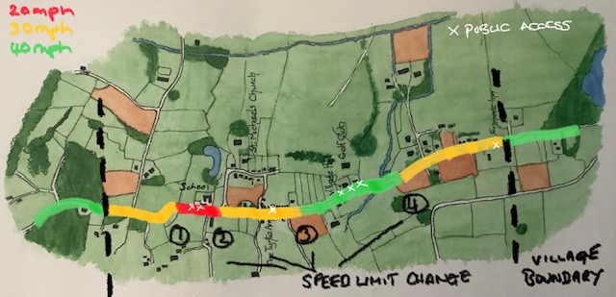

On 7th September 2021 a record number of Enmore residents turned up to a Parish Council meeting where there was a discussion regarding the speed issues that had been under observation by the local police in liaison with the Enmore Parish Council.

It was clear from the public discussion that there was great concern about:

1. the speeds that were being observed were in total disregard for the displayed limits
2. the fact that there were multiple different speed limits within the village
3. **the road, that has no pavement or cycleway, was used by a wide variety of users - pedestrians (including children), joggers, horses including racehorses, tractors and other farm traffic, moving farm stock, cyclists (it is on a key National cycle route), motorbikes, cars, vans, transit vans and delivery articulated lorries**
4. the 40mph section was absurdly where the road had several blind bends and the adjacent entry/exits for both the Village Hall and Enmore Golf Club but still motorists were dangerously overtaking other vehicles
5. the 20mph limit by the school that is 24/7 was being largely ignored outside school hours as it was seen as irrelevant at weekends and school holidays.
6. outside the school is a high risk area at school drop-off and pick-up times
7. the police speed traps were only there during the day and not during morning and evening commuter traffic
8. anecdotal stories of near misses involving horses
9. the volume of traffic was clearly increasing, borne out by the repeated repair of the road
10. the route was being increasingly being used to avoid congestion of the M5 and A38 between Taunton and Bridgwater (both of which have been subject to major road works and road/lane closures)
11. the signage was declared woeful and inadequate, including road markings

**Parish Council Decision:**

**As a result of this meeting, together with the information that had been collected by the police, it was decided to proceed with discussions regarding the purchase of SIDs by Enmore Parish Council.**

**Background contd.,**

**Emails Received post meeting by Phil Dodden, then Enmore Parish Councillor responsible for Road Safety**

Dear Phil,

First of all I would like to thank you for all your efforts on the "Enmore road" front. It was a worthwhile meeting this evening.

If I may I would like to note down several points I would like to make.

1. There would be few stretches of road anywhere which are classed as one village which have multiple varying speed limits that also include a 20mph which is 24/7.
2. The road carries some regulars - villagers, parents/carers to the primary school, commuter traffic. It also carries an increasing number of unfamiliar users - couriers, tourists, M5 and A38 avoidance users aided by Google. It is also a cycle route known well as to be a part of the Lands End to John o'Groats route and various well known cycle races. The Enmore Road and indeed the topography of the route between Bridgwater and Taunton is not fit for the marriage of all these purposes.
3. I was unhappy to hear that we should instil fear into drivers by the regular use of the "Super Stealth camera" as a way of dampening the speed. This will only affect regular users, it will have little impact on Enmore village by catching unfamiliar, one-off users. I appreciate this is also collecting numbers but it is not recognising the root of the problem.
4. Alternative routes to M5 congestion should be on the radar of the Avon and Somerset police as possible hotspots to be revisited to make them as safe as possible.
5. Proactive prevention not waiting for a well understood risk to actually occur.

In short, we need to revisit the speed levels and signage through the village. A suggestion, which I do not know if is legally feasible but should be revisited at the Highways level, would be starting from the top of the village:

1. Go from 40 to 30
2. Rumble strips before change to 20 outside school but with the proviso in point 3 below
3. 20 outside school to only be operational during school day and in termtime otherwise 30
4. 30 to be throughout whole village until it changes to 40 after Enmore Inn changing back to 30 where it currently does near Goathurst turn before narrowing of road. This will ensure 30mph past VH and Enmore golf course.
5. And 30mph to be painted on road at regular intervals.
6. Install flashing speed controls at each end of Village alternating use every two weeks.
7. Put up signs that there is Farm and horse traffic.

Unfamiliar users must be made aware of speed and hazards to give them a heads-up. We have a lot of non-country drivers who pass through.

I am sincerely not happy with the fear approach to control. Clear sensible signs and flashing warnings of excess speed always, in my experience, slows down the vast majority of traffic.

A sign at each end also thanking people for driving safely through our village would not go amiss!!

Best

**Background contd.,**

Dear Phil

Since writing my email to you I have made some further observations.

**Push for 30mph through whole village between Village signs at either end**

A consistent 30mph

* Is easier for a motorist to maintain and focus concentration only on other village road hazards (and not get fed up and ignore multiple changes in speed limit in the one village entity)
* Is greener for the environment
* Is safer as the current 40mph interruption passes entrances to a frequently used Golf Club and Village Hall both of which are on bends. In fact the only stretch of the village that has blind bends and rises is set at 40mph which implies speed can be increased safely which is not the case!
* Is safer to manage the shared use by farm traffic and horses
* It is proven by the Highways Agency themselves that enforcing speed consistency improves traffic flow, is quieter, safer and greener.
* Links the village as one entity for the motorist who will be mindful for its duration that they are in a village environment.

**Better signage**

* Our signs are currently woeful. Obscured either by foliage or painted out.
* Asking around there is unanimous consensus that nobody becomes immune to flashing speed indicator signs.  Everyone said they welcomed the confirmation that they had got either their speed right or as a reminder to ease off a bit. (Kingston is a case in point although it would be hard to speed through their village!)
* The current speed watch placards have indeed slowed the general traffic as they are reminders to watch your speed. Also for those infrequent users who are unfamiliar with the road it is a sign they noticed and seem to take heed of.

**Enmore School**

* The 24/7 20mph is a nonsense and “encourages” lack of notice for out of school hour motorists who are already descending a hill from 40 to 30mph.
* It would be safer to make it 30mph and 20mph during school hours with solar powered flashing 20 in red when active.  An advance warning notice should also be erected near earlier village sign to give prior alert to motorists and also coming up the hill from the village.

I believe we should be better managing the changing traffic use of the Enmore Road and primarily we can do this through reconfigured speed limits that are better in tune with its current usage, more speed alert signs such as flashing speed signs and then use the irregular mobile stealth camera to catch those true speedsters who deliberately and always ignore speed limits.

The deteriorating road surface and the need for regular maintenance signals the increased heavy usage of the Enmore Road and the need for better Highways Agency management.  It is only recently that we have had a gritter along the road during icy conditions which is Highways Agency recognition of heavier use.  We should therefore be able to put a case forward to alter the speed limits through our village in recognition of all that I have mentioned.

Kind regards

**Phase 1 - Installation of SIDs by Parish Council**

**Phase 1A – Installation of first three SIDS**

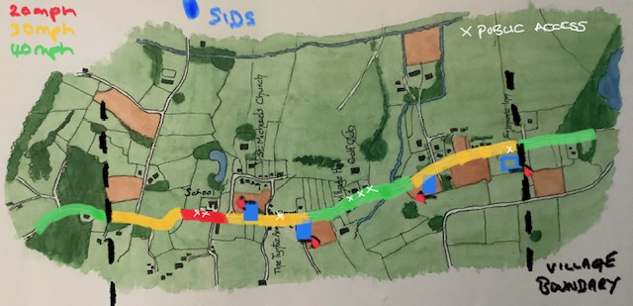

Initially, in August 2021, the traffic police installed a data collection box (no display) outside Enmore School.

The number of vehicles that passed by in either direction was 25561 and 24172, 95% of which was travelling at above the 20 mph speed limit and 15% above 40 mph. The maximum speed was an unbelievable 86 mph.

This data was sent by David Comley of Enmore Parish Council to Katherine Tyson in the Highways Department and convinced her to support the Enmore Speed Management project.

The first SID started to collect data on 24 July 2022 and has been in operation for 161 days. During this period there have been 144,000 vehicles travelling in each direction or approximately 1800/day in both directions.

The SID was in spy (no display) mode for the first two weeks after which time the display was turned on.

30 mph section

When the first SID was in spy mode, 54% of vehicles met the 30 mph limit and this improved to 80% with the display active.

The display was then turned off and the speeds immediately returned to pre-SID patterns.

Over the following weeks the <30 mph percentage has remained fairly constant at 80% +/- 1% when the SID is active.

The second SID was installed at the start of Upper Enmore coming from the school and when active, its  
<30 mph data is 77% +/- 2%.

The third SID located opposite Stone Hall Lane, when active, shows <30mph data is 73% +/- 1%.

**Phase 1 - Installation of SIDs by Parish Council contd.,**

Approaching 40 mph section from both directions

Coming out of Upper Enmore towards the Golf Club and into the 40 mph section and passing the back of the 2nd SID, only 44% are driving at less than 30 mph, clearly accelerating towards the 40mph limit.

Coming out of Lower Enmore towards the golf club passing the back of the existing 3rd SID and into the 40mph section, the number driving at less than 30 mph, is only 37%. In this direction drivers have not yet seen a warning display as the 4th SID is not yet installed at the approach of the 30 mph before Enmore Inn in Lower Enmore.

**Phase 1b completion by March 2023 - All Four SIDs installed**

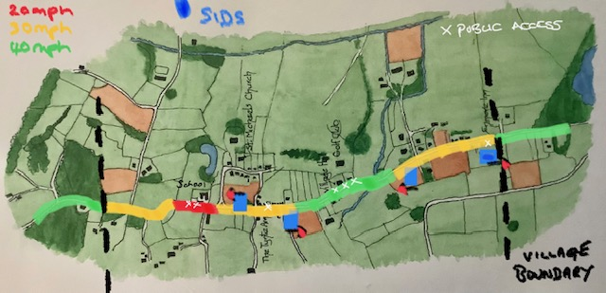

**Phase 2 – Install 30 mph through whole village**

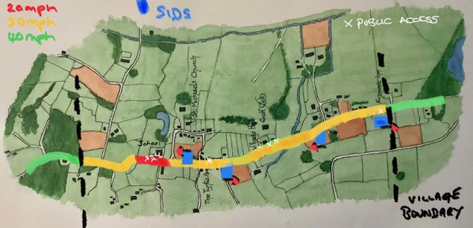

The current 40mph section:

1. is the section of the village where there are blind corners, undulating topography and a section prone to flooding.
2. it has entry and exits to two car parks adjacent to each other. One is for the Village Hall which is used regularly but is surpassed in numbers by the heavily used carpark of Enmore Park Golf Club. Enmore Golf Club is used by an estimated 120 vehicles/day during the winter increasing to 180 vehicles/day during the summer.
3. both these carparks sit close to a bend where passing traffic is accelerating out of one 30mph section before hitting the next.
4. local residents, who are the minority of road users, are aware of the hazards in this 40mph section and would therefore be more likely to decrease their speed on this section of the road than increase it.
5. the change to a 40mph limit is giving a very misleading message to motorists not familiar with the road (which represent the majority of traffic) about a driving speed appropriate to the terrain and potential hazards.

**It is proposed by the Enmore Parish Council that this 40mph section be changed to 30mph.**

There are two 40mph signs at each end of the section, 3 smaller double sided 40mph signs along the section and one 40mph road marking at each end that will need replacing by 30mph.  As the posts exist this should not be a costly exercise nor changing a 4 to a 3 on the road although this could just be tarred over when next resurfaced.

The road resurfacing people are regular visitors to the Enmore Road.  The yellow road markings alerting motorists to the changed speed can remain in place as it will now alert motorists that they are entering the section of Enmore Road that has blind corners and undulating topography instead.

**Phase 3 – Enforce 20mph outside school during school hours only**

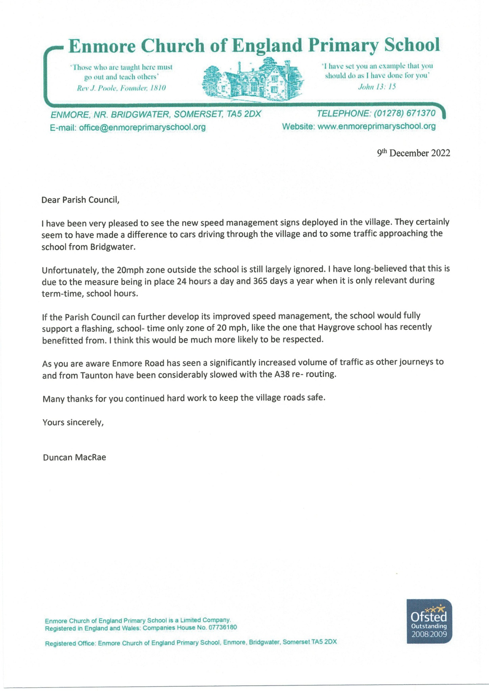

**Phase 3 – Enforce 20mph outside school during school hours only contd.**

The school sits at the bottom of a long hill where the traffic has already slowed from 40mph to 30mph, negotiated a blind corner before hitting a 24/7 20mph sign that is in force until the top of another decline into the village itself, where it changes to 30mph. As articulated in the letter to the Enmore Parish Council from Mr Duncan MacRae, the headmaster of Enmore Primary School, the current 20mph limit outside the school is largely ignored as it is considered unreasonable for it to be enforceable 24/7.

The 24/7 20mph outside our school is also out of step with many other schools in the area, an increasing number of which have a system of flashing lights controlled by the school and operated only when needed, and a normal, typically 30mph, speed limit at other times.  Enforcing an unreasonably low limit at all times of the night and throughout the school holidays brings speed limits into disrepute and only serves to irritate the most law-abiding drivers – the limit is widely flouted.

The data collected by the traffic police outside Enmore School in August 2021 was that the number of vehicles passing by in either direction was 25,561 and 24,172, 95% travelling above 20mph, 15% above 40mph. The maximum speed recorded was 86mph!

Enmore School would therefore welcome a change to a limit of 30mph, with a reduction to 20mph when lights show.  It is their opinion that road safety in the area of the school would be improved by greater compliance with a speed limit regarded by drivers as reasonable.

**In line with the push to have the whole village from start to finish 30mph, it would make clear sense to a motorist if the road outside the school was 20mph by exception only, highlighted by the installation of flashing lights as outside Haygrove School in Durleigh and North Petherton Primary School in North Petherton.**

**We would also comment that Enmore Primary School recently had its Outstanding Oftsed status renewed (November 2022), only the third school in the South West to do so, and as a flagship school and a credit to Somerset, we hope that its road safety concerns will be taken seriously.**

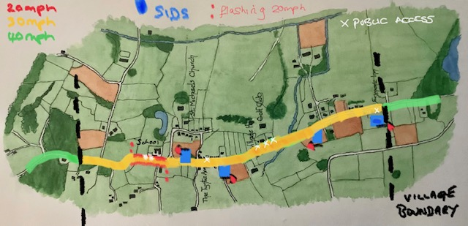

**Phase 3 – Enforce 20mph outside school during school hours only contd.,**

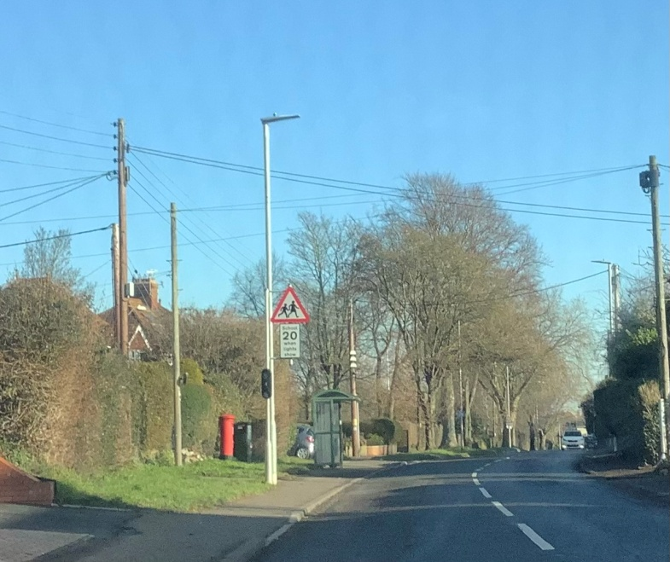

Haygrove School, Durleigh, Bridgwater

Recently installed flashing 20mph speed limit during school hours only and within 30mph speed limit

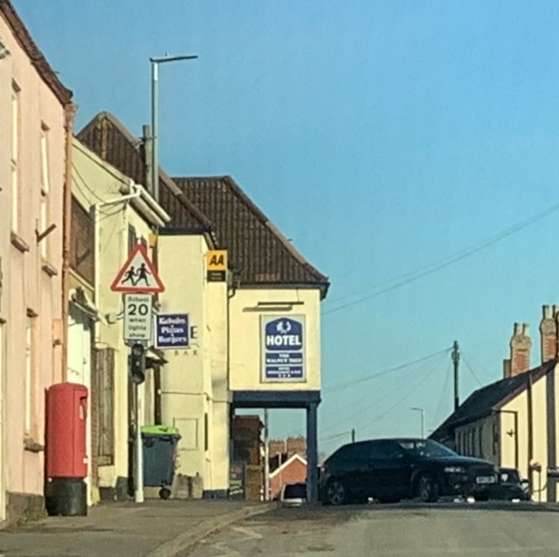

North Petherton Primary School, North Petherton, Bridgwater

Recently installed flashing 20mph speed limit during school hours only and within 30mph speed limit

**Summary**

Enmore Parish Council has conducted due diligence in its efforts to improve safety on the Enmore Road within its Village environs.

Police-collected evidence has subsequently been supported by data collected from the three SIDs currently installed and purchased with Parish monies. These data show that the current speed limits are grossly ignored and only observed when the SIDs are in operation.

The four speed limit changes between the Village signs at each end of the village are not encouraging motorists to give safe passage to other (non-motorist) road users who frequently pass along the Enmore Village Road.

Four speed limit changes along such a short stretch of road is not only confusing but also not environmentally friendly to the countryside or to the people who live along it.

The Enmore Road is a well-known alternative route to the M5 and A38. The Highways Department has not been mindful of the increasing level of danger that now exists for Enmore Road users that has risen in line with the increasing volumes of non-local traffic.

**Two straightforward amendments by the Highway Department are requested:**

1. **A 30mph speed limit for the entire length of Enmore Village and**
2. **To convert the current 24/7 20mph limit outside the school to a flashing “school hours only” sign**

**Together with the Parish funded four SID installations, these changes would not only increase the safety along the Enmore Road but also appear to the motorist as a logical, well thought out and “to be respected” speed management program through a country village.**

**At the moment, the Enmore Village Road is a high risk zone with “fault” to be found on its current Highway speed management.**